USB Blaster

1. Connect the FPGA board to a USB port on your computer. Then open the device manager in Windows: Press the Windows logo key and R and Enter the command "devmgmt.msc" and press OK. Alternatively, you can right click “This PC” and click “property” to open Device Manager. You should see the USB-Blaster listed under Other devices.

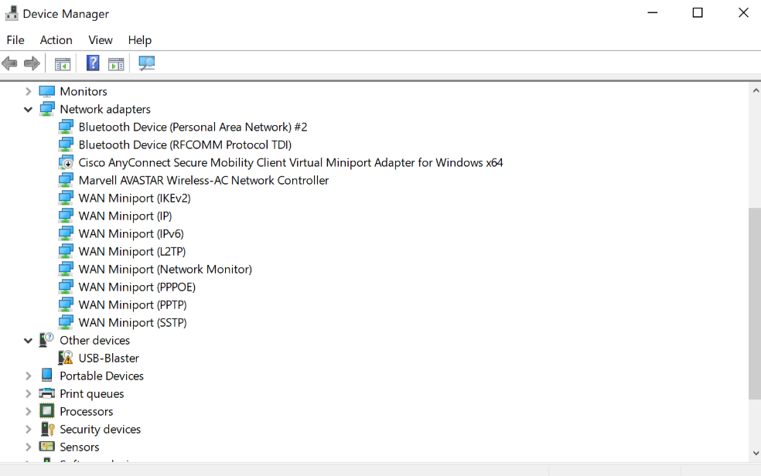

2. Update USB Blaster Driver

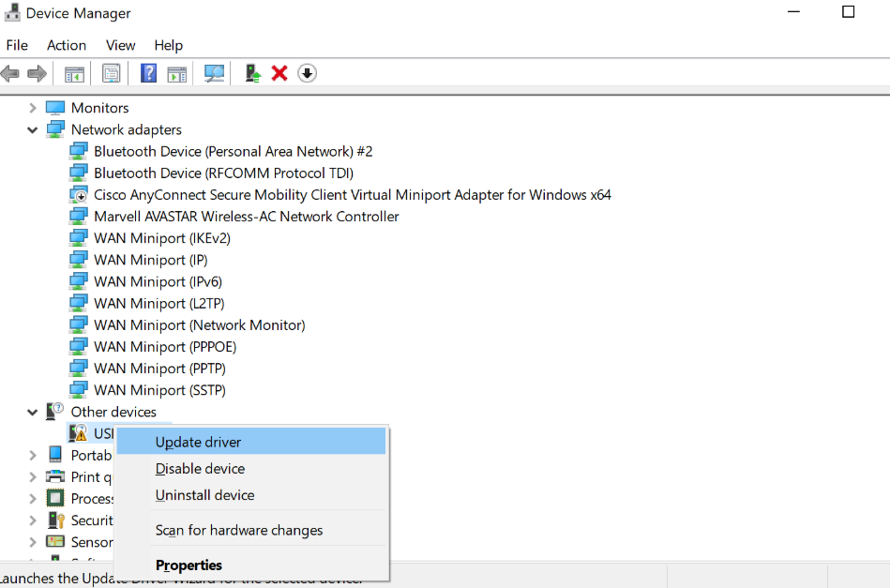

Click “Browse my computer for driver software”

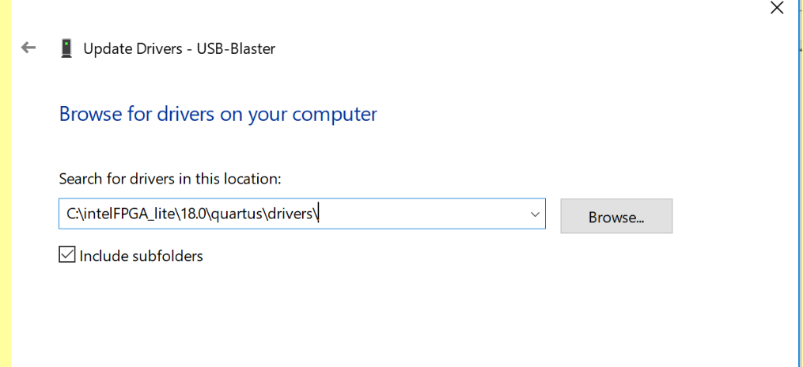

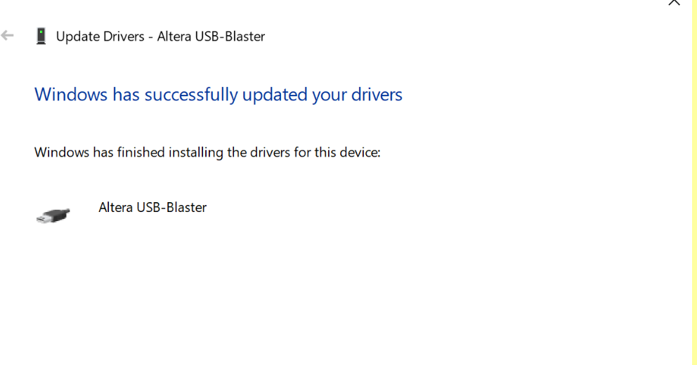

3. Open Quartus ii and check if USB blaster was installed successfully. 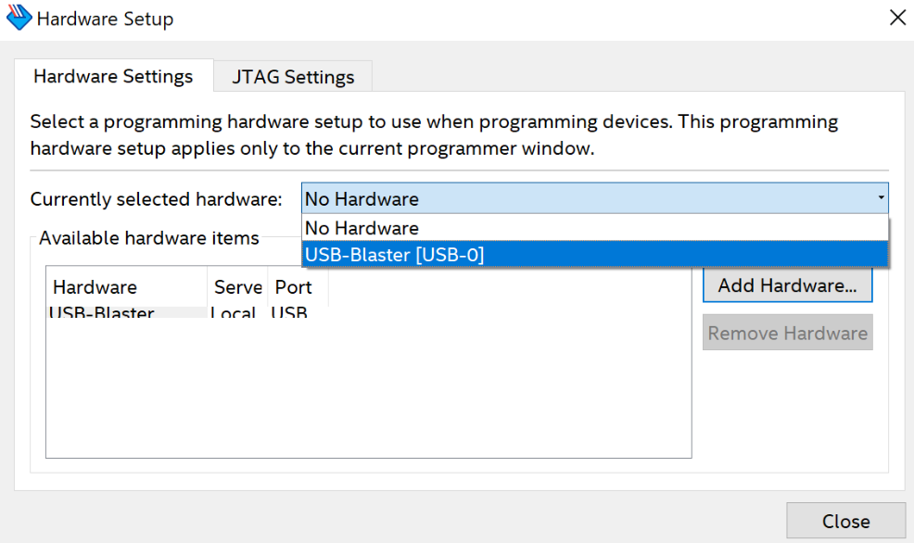

4. If it still doesn’t work, go to webpage <https://www.terasic.com.tw/cgi-bin/page/archive.pl?Language=English&CategoryNo=163&No=502&PartNo=4>

to download a new USB blaster Driver. The cd-rom file includes usb blaster driver